eDAI Python Programming Module End Examination - March 2022

There are 20 Objective questions(i.e. Multiple Choice Questions) and 7 Descriptive questions( 5 short answer type and 2 Long Answer type) in this examination paper. Each objective question carries 01 mark. Each short answer descriptive question carries 02 marks and Long Answer type carries 10 Marks . There is no negative marking for objective questions. Total duration of exam is of 1hour 45 minutes. . After Question No. 40 , click on Next Option to view section of descriptive questions.

* Required

Email*

shewalek3004982@gmail.com

16 of 20 points

Name*

/

0

kalyani kailas shewale

Add individual feedback

Q5. What will be the output after the following statements?

/

1

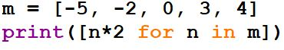

[-10, -4, 0, 6, 8]

[10, 4, 0, 6, 8]

[-10, -4, 0, 6]

[-10, -4, 0]

Correct answer

[-10, -4, 0, 6, 8]

Add individual feedback

Q8. What will be the output of the following Python code?

/

1

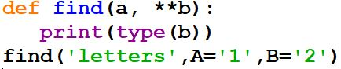

String

Tuple

Dictionary

An exception is thrown

Correct answer

Dictionary

Q10. To read the entire remaining contents of the file as a string from a file object infile, we use ____________

/

1

infile.read(2)

infile.read()

infile.readline()

infile.readlines()

Correct answer

infile.read()

Q18. Which of the following functions converts date to corresponding time in Python?

/

1

strptime()

strftime()

Both of the above

None of the above

Correct answer

strptime()